Problem B： USVs(Unmanned Surface Vehicle) clusters cooperate to fight

The new generation of artificial intelligence technology and independent technology will quickly go to the battlefield, which will give birth to new combat forces and subvert the traditional war mode. The future war will be an intelligent war. As an important form of intelligent combat, USVs (Unmanned Surface Vehicle) cluster combat is emerging. Through cooperative reconnaissance, cooperative detection, cooperative tracking, cooperative attack, cooperative interception and so on, many complex combat tasks are completed together.

The problem of cooperative confrontation between the Red and Blue USVs clusters in the sea surface area is considered. As the **attacking side, the Blue team** hopes to break through the interception of the Red team and successfully reach the destination and carry out military operations; the Red team hopes to complete the interception of the Blue team in a given area to prevent the Blue side's penetration. The confrontation area discussed in this situation is a rectangular area (as shown in Figure 1) $ABCD$. Attack depth (the distance between *BC*) is $L=10km$. The track of Blue team cannot cross both sides $AD、BC$, that is, the attack channel (penetration corridor) bandwidth has a constraint. The distance between channels (i.e. bandwidth) $AB$ is recorded as $M$. The speed of the Blue USV is $V_{E}=25m/s$. The minimum turning radius 最小转弯半径 is $R_{E}=100m$. The speed of the Red USV is $V_{P}=20m/s$. The minimum turning radius is $R_{P}=80m$. The speed of the Red and Blue USVs is considered as constant. The direction of the motion can be changed at any time according to the need of maneuvering strategy, but limited by turning radius. The USVs of Both sides are equipped with detection devices and data chains, which can accurately detect the USVs’ real-time positions for all the USVs (both Red and Blue). In view of the advantages of Blue USVs in maneuvering speed, the Red side considers making up for the disadvantage performance through the cooperation of multi-USVs (i.e. through the advantage of quantity) in order to improve its confrontation effect. The USVs of the Red side carrying out the interception mission拦截任务 is carried to the attack position by USVs Carrier, and then a certain number of USVs are released according to the need of the confrontation, and the USVs cluster is formed to confront the USVs of the Blue side. As shown in Figure 1, in order to prevent the penetration of the Blue UAV, the Red side consists of two USVs clusters released by USVs carriers $FY01$ and $FY02$. Each USVs carrier releases five USVs. When **the distances between the Blue side penetration USV and at least two USVs from the Red side are less than $R=100m$, it is considered that the Red side has successfully intercepted the Blue side** penetration USV. At the same time, according to the mission requirements, **the Blue side UAV needs to cross the boundary $CD$ inside $700s$.** Otherwise it is regarded as a failure of penetration. Both sides want to make full use of their own advantages, through the use of optimal maneuvering strategy to achieve the purpose of penetration and interception.

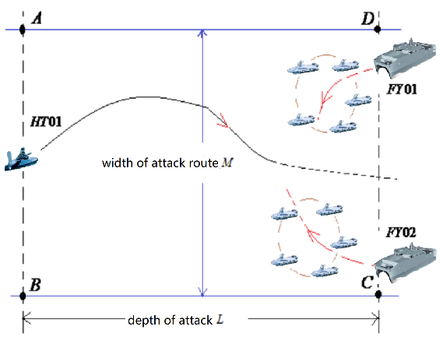

Figure 1 Red team intercept a Blue team diagram

The Red team USVs cluster can sail in certain formations according to the actual needs. As shown in Figure 2, the Red USVs cluster adopts one of the formations. Five USVs’ positions are approximately distributed on a circle. The spacing between any two adjacent USVs is the same. In order to control, communicate and avoid collision, the distance between any two UAVs on the Red side should be greater than $30m$. The distance between each UAV and at least two UAVs in this cluster is not greater than $100m$. The distance between the Red USVs Carrier and at least one UAV in the UAVs cluster is not more than $2km$. The distance from the Blue penetration UAV should be greater than $1km$. The speed of the **Red USVs Carrier** is not more than $V_{C}=16m/s$. The turning radius is not less than $500m$. The tracks of Red USVs Carrier and USVs are not restricted by the boundary *ABCD*.

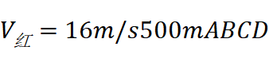

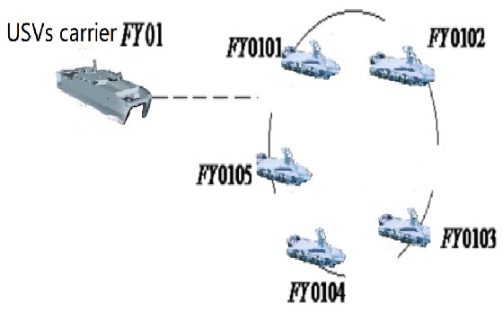

Fig 2 illustration of the formation of USVs cluster released by the Red team USVs Carrier

The USVs’ number released by the USVs Carrier $FY01$ is recorded as $FY01××$. Therefore, the five USVs’ numbers in figure 2 are respectively recorded as $FY0101$, $FY0102$, $FY0103$, $FY0104$, $FY0105$. The USVs’ number released by the USVs Carrier $FY02$ is recorded as $FY02××$, and so on. The USVs in the USVs cluster is uniformly distributed on a circle at the initial time.

In practice, it takes a certain time for USVs Carrier to set up the USVs cluster. In order ton simplify the calculation, this situation does not consider this time limit, can be regarded as the instantaneous layout 瞬时布局of the USVs cluster, and meets the relevant constraints. In the course of confrontation, the whole flight is not required according to a fixed formation, and the formation can be adjusted at any time according to the need.

require your team to study the following questions by building mathematical models:

Question 1：

As shown in figure 3, at the beginning of the confrontation, the circumferential centers 圆心of the two USVs clusters in the Red side are respectively located at $G_{1}$ and $G_{2}$, the radius of the circumference is $50m$. where, $DG_{1}=2km$, $G_{1}G_{2}=3km$, $CG_{2}=2km$. Please build your model and analyze **where the Blue UAV is in the rectangular area $ABCD$**, no matter what kind of pursuit strategy the Red UAVs adopts, the Blue UAV can always adopt the appropriate strategy to **avoid the Red side interception and realize the successful penetration**. Please discuss **the optimal penetration strategy of the Blue UAV**.

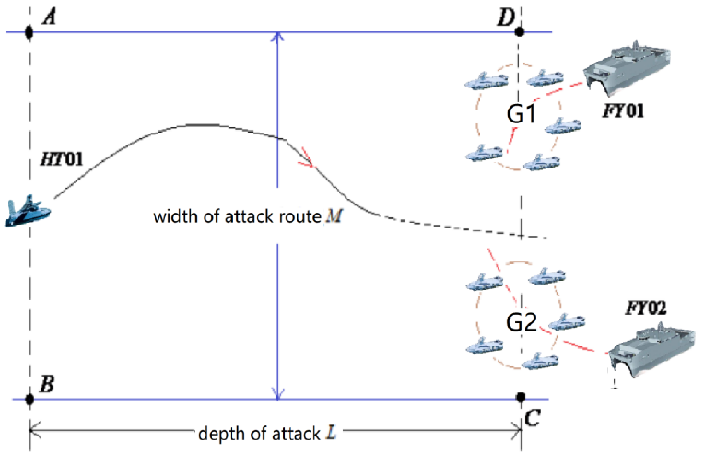

Fig 3 The initial central position of the Red team’s UAV cluster

Question 2:

as shown in figure 4, the **Blue UAV is located at the center of the boundary $AB$**  at the beginning of the confrontation. The circumferential center of the two UAV clusters of the Red side is located at $G_{1}$ and $G_{2}$. The radius of the circumference is $50m$. $G_{1}$ **and $G_{2}$ are located on the boundary $CD$. The specific location shall be determined as required.**

Please build your model and analyze **whether or not** the lower limit $M_{min}$ of channel bandwidth $M$**is existent**. When the actual channel bandwidth $M$ **is greater than $M_{min}$, the Blue UAV can break through** the interception of the Red UAVs cluster. And, please give the **shortest time penetration strategy** of the Blue UAV in this case.

Please build your model and analyze whether or not the upper limit $M_{max}$ of channel bandwidth $M$ is existent. When the actual channel bandwidth $M$ **is less than $M_{max}$, the Red USVs cluster can intercept the Blue USV**. And, please give the **interception strategy** of the Red USVs cluster in this case.

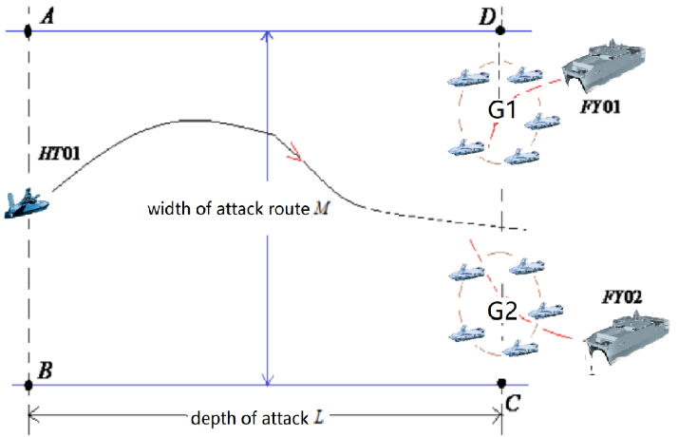

Fig 4 diagram of the initial position of UAV cluster

Question 3:

each carrier can release 10 USVs in two times, forming two USVs clusters to carry out the interception. the number of USVs in each cluster is not less than 3. Every time, the initial formation of UAVs cluster is shown in Fig 2. The distance between the carrier and the center of the circle is $200m$. The formation of UAVs cluster can be adjusted according to the need, but the corresponding spacing constraint is required. As shown in figure 5, at the beginning of the confrontation, the Blue USV is located at the center of the boundary $AB$, with channel bandwidth $M=10km$. The Red two USVs Carriers are located at points $G_{1}$ and points $G_{2}$ on the boundary $CD$, and began to release the first wave of USVs clusters. The specific location of the USVs cluster center and USVs Carriers can be determined according to the needs. When the USVs Carriers realease the second wave of UAVs cluster, it is necessary to ensure that the carrier and the first wave of UAVs cluster meet the constraints of spacing.

Please **discuss the number of UAVs released in two times**, **the time and position** of the second release of each Red carrier and **the central position** of the UAVs cluster released in the second time, in order to achieve the optimal interception effect.

Please build your model and analyze **whether or not the upper limit $M_{max}$ of channel bandwidth $M$ is existent**. When the actual channel bandwidth $M$ is less than $M_{max}$, the Red USVs cluster can intercept the Blue USV in the rectangular area $ABCD$, whatever Whatever penetration strategy is used by the Blue USV. And, please **give the interception strategy of the Red USVs cluster** in this case.

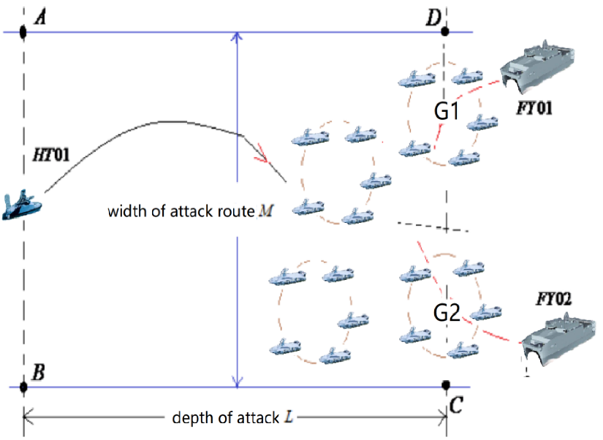

Figure 5 diagram of the Red team USVs Carrier launches two USVs cluster interception

Your solution of no more than 22 total pages should include:

* + One-page Summary Sheet.
  + Table of Contents.
  + Your complete solution.
  + References list.

**Note:** All aspects of your submission count toward the 22 pages limit (Summary Sheet, Table of Contents, Reference List), but Appendices are not counted.